Design Level Class Diagrams

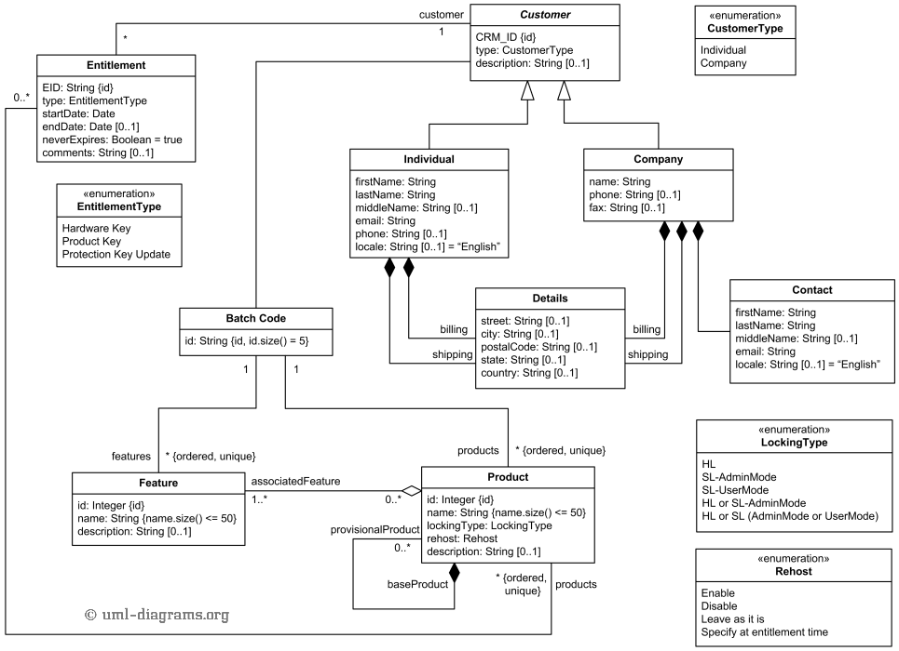

Figure : Class diagram

*Note: this is just an example. Replace it with appropriate diagrams*